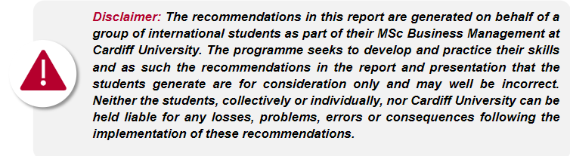

Group S1-G13 Supv-Andrew Burnett  
Mehul Bauskar 23081090  
 Saharsh Jaiswal Dilip 23053806  
 Kai Wu 23107812  
 Zihan Lou 23013033  
 Rishimaran Elamaran- 23036224

Crowdfunding Strategy for Samye Foundation Wales

A Comprehensive Approach to Fundraising for Operational Costs and the Mother Earth Project

Table of Contents

Executive Summary 2

Introduction 2

a) Samye Foundation Wales 2

b) The Mother Earth Project 2

c) Problem Statement 3

d) Scope and Objective 6

Crowdfunding Landscape Analysis 6

Overview of the Crowdfunding 6

Analysis of successful Crowdfunding campaigns in the charity sector: 7

Key platform & their suitability for the Samye Foundation Wales charity 7

Competitive analysis of similar Crowdfunding campaign 9

Target Audience Analysis 10

Crowdfunding campaign development 13

Campaign messaging and storytelling 13

Reward Structure for the Donors 15

Campaign timeline and milestones 16

Digital marketing and social media strategy 16

Monitoring, Evaluation and Learning 20

Monitoring Strategy 20

Evaluation Methods 20

Learning and Adaptation 21

Recommendations 21

Prioritised recommendation 21

Implementation Plan, Ongoing support and Evolution 23

Ongoing Support: 23

Evaluation Approach: 24

Reference 25

Appendix 27

Problem Statement 27

Gantt Chart 27

Ethical Certificate submission Proof 27

Questions & Feedback 28

## Executive Summary

Samye Foundation Wales, a mindfulness and well-being centre in Cardiff, has been encountering financial troubles after losing donations during the pandemic. Currently working at a loss and offering solidarity to receive funding specifically for the Mother Earth Project through crowdfunding campaigns. Since the client has no budget to spend on advertising we made some recommendations accordingly. The plan will emphasize use of Crowdfunder UK as the main platform being particularly for charities and community projects in the United Kingdom. It focuses on specific donor segmentation targets — people who love being mindful, individuals passionate about mental health and folks dedicated to the environment. The strategy also advises the need to follow through on these messages with a tiered reward structure, and comprehensive digital marketing plan would be needed that does not require costs but works within existing hiring platforms like LinkedIn (which recruiters already use), as well other free tools. The timeline of the campaign is scheduled with milestones marked along each step, and checks suggest that a monitoring evaluation and learning mission can be useful to further strengthen performance. Samye Foundation Wales have a considerable advantage in their existing capacity and experience in mindfulness training, as well as networks of people who are receptive to this type change. With low-cost crowdfunding approaches such rewarding success should also be replicable with relative ease for them over the next few months if they wish.

## Introduction

* 1. Samye Foundation Wales: Samye Foundation Wales is a centre for mindfulness and well-being, based in Cardiff which provides an extensive range of support services. The foundation also offers expert-led mindfulness courses, meditations and workshops to help people reduce stress by using Mindfulness techniques. With gardens, facilitated sessions and one-to-one help from trained psychotherapists and counsellors, visitors can spend quiet time away. Furthermore, the centre provides holistic wellness approaches such as Tai Chi and Qigong, yoga and complementary therapies. Providing free mindfulness classes & affordable room hire for community events we support accessibility. Providing a platform endorsing inclusiveness, the foundation caters to all audience types thus creating an ideal ambience for personal and social enhancement (Localgiving, 2024).
  2. The Mother Earth Project: An Environmental Initiative within the Samye Foundation Wales as for Sustainable living (Samye Foundation Wales,2024). The objective of the project is to establish hope for our planet & literacy around mindfulness and taking care of the environment. The program includes workshops in sustainability, mindfulness and conservation with an emphasis on protecting bees. Its work in conserving bees has seen it win a Bee Friendly/Cary Gwenyn award. Mother Earth Project also involves the community by reducing their consumption of plastic, saving energy, recycling well and awareness-raising on environmental issues.

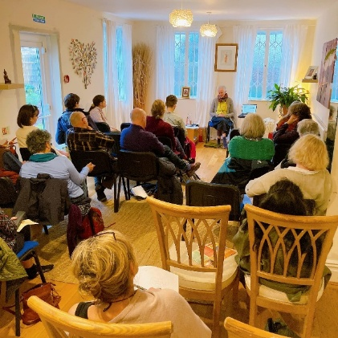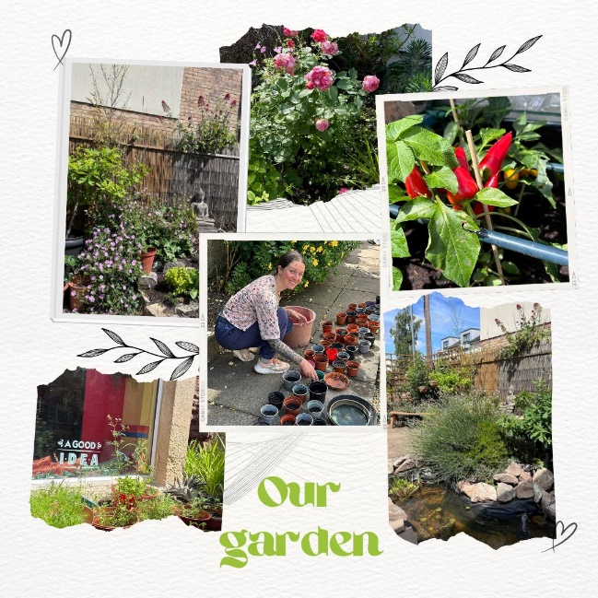

Fig 1: Glimpse of Samye Foundation Wales   
Source: *Samye Foundation wales: Cardiff* (2024) *Facebook*

* 1. Problem Statement: The Cardiff Business School has approached Samye Foundation Wales for a strategic consultancy advisory provided by MBM (MSc Business Management) students. After meeting Jessica Davies and Lorraine Harris from Samye Foundation Wales charity, we have understood that there has been a decline in donations to the charity from volunteers and government bodies after COVID-19. In a survey conducted by the Charities Aid Foundation, it was found that 58% of charity leaders cited generating income and finding financial stability as one of their top three challenges for the year ahead (Covid Aid, 2022). The decline in funding has led to SFW Charity's operational deficit. As per Charity Commission for England and Wales - Charity 1122144 (2022), Samye Foundation Wales reported a total income of £50,146 and a total expenditure of £66,913 for the fiscal year ending December 31, 2022. This indicates the charity is currently operating at a deficit, which makes fundraising efforts particularly important. To sustain and support people, the charity has decided to go for crowdfunding. They want to raise funds for operational needs and the Mother-Earth project. Fig 2: CFA Data 2023, depicts the slowdown of donations by individuals and the potential losses.

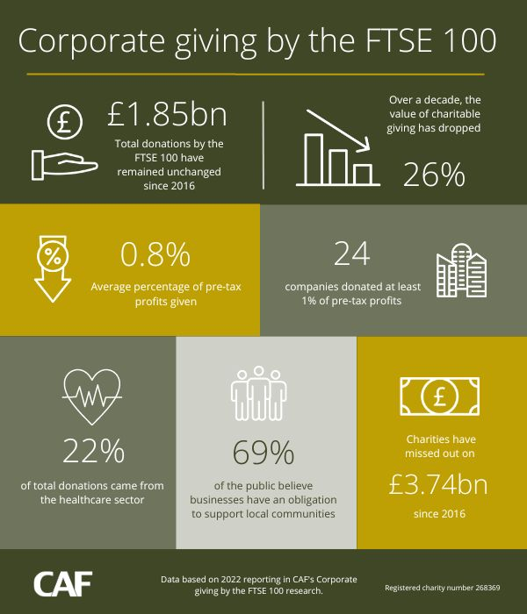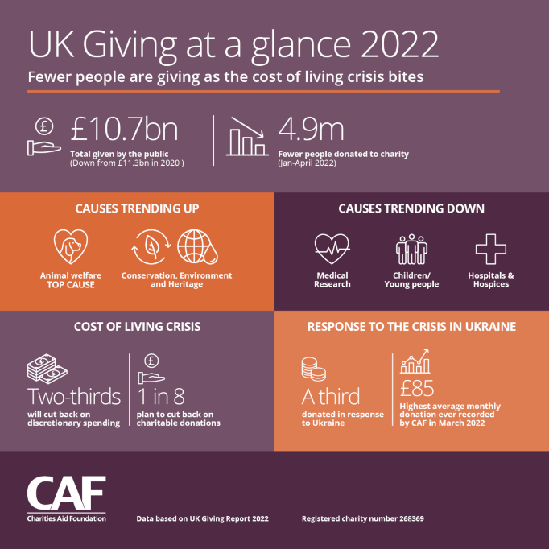

Fig 2: CAF Data 2023  
Source: Charities Aid Foundation. (2023) and NICVA (@NICVA). (2022)

The Fig 3, SWOT analysis shows the strengths which SFW can take advantage, weakness to rectify, opportunities to grab and threat to be cautious off. The analysis helps to generate a problem tree (Fig 4), mentioned below, which helps in understanding the sectors to research.

Threats

Competition from other mental health and wellness charities for donor attention

Economic uncertainties affecting individual giving

Potential donor fatigue due to numerous charitable causes

Changes in crowdfunding platform policies or fees

Rise of mindfulness Apps and courses.

Weaknesses

Currently operating at a financial deficit.

Limited experience with crowdfunding campaigns

Seasonal closure may impact campaign momentum.

Reliance on volunteers may limit dedicated resources for campaign management

Reputation over 10 years

Mission focused on improving mental health and well-being through mindfulness.

Strong volunteer base of 50 individuals

Diverse offerings including mindfulness courses, complementary therapies, and counselling

Strengths

Opportunities

Growing public interest in mental health and well-being.

Potential to leverage existing corporate relationships for matching donations

Ability to offer unique mindfulness-related rewards for campaign backers

Possibility to engage the local Cardiff community through targeted campaigns

Fig 3: SWOT analysis - Crowdfunding for Samye Foundation Wales.  
Source: (Samye Foundation Wales, 2024), (Charity Commission, 2024)

Problem Tree Analysis of Crowdfunding Campaign for Samye Foundation Wales

1. Crowdfunding Landscape Analysis
   1. Analysis of successful crowdfunding campaigns
   2. Key platform and their suitability
   3. Competitive analysis of similar organization.
2. Target Audience Analysis
   1. Identification of potential donor segments
   2. Donor personas and motivations
   3. Communication channels and performance
3. Crowdfunding Campaign Development
   1. Campaign messaging and storytelling
   2. Reward structure and milestone
   3. Digital marketing and social media strategy
4. Monitoring, Evaluation and Learning
   1. Key performance indicators [KPI]
   2. Data collection and analysis
   3. Learning and adaption

These are the sectors in which analysis and work need to be done to achieve a successful crowdfunding project. Crowdfunding is a modern fundraising method which allows organization to raise small amounts of money from a large number people, typically via the internet. It was represented as an alternative to more traditional types of financing such as bank loans or grants and argued that this rendered it a particularly attractive option for the non-profit sector, in addition to improving opportunities for smaller organizations who might encounter hurdles when trying other funding sources (Business Wales 2024). Crowdfunding has been the perfect strategic move that Samye Foundation Wales needed to reach many more people and raise enough funds for their different projects. Using crowdfunding platforms to put out powerful campaigns allows the foundation, or nonprofit group behind such projects as they grow their operations like Amor Mater can raise awareness of those costs in a digestible fashion for potential donors. This helps them realise their financial ambitions and also drives publicity around its mission, possibly increasing the number of supporters for what it stands for and inspiring greater community involvement (Business Wales 2024).

* 1. Scope and Objective: To empower the volunteers of the Samye Foundation Wales charity with knowledge backed by eminence research which will help the charity to raise funds through crowdfunding campaigns. The crowdfunding campaign will have a target and period as mentioned in Table 1.

The report has information regarding fields in which the charity should work on and how to monitor those sectors while doing crowdfunding which will led to success in achieving targeted results for the charity.

|  |  |  |
| --- | --- | --- |
|  | Operation project | Mother-Earth Project |
| Founds to raise | £33,000 | £20,000 |
| Time period | 3 years | 6 months |

Table 1: Target for Crowdfunding Campaigns

## Crowdfunding Landscape Analysis

### Overview of the Crowdfunding

Crowdfunding has enabled UK charities to fundraise in a new and exciting way by appealing directly to the public via online platforms [VWV, 2024]. Increased reach; ease of use and ability to engage supporters more directly (Nesta, 2024). Yet, crowdfunding is faced with its own challenges; apart from the fact that it requires individual campaigns to have projects and defined outcomes for funding (NCVO), also many donors are interested in Gift Aid on their donations however unregistered non-charities will not be able utilise this benefit as most recognised charity funders would allow. Overcrowding of charities undermines the ability for an organization to grow, but as noted by Good Finance (2019), there is a significant scope in this space where huge opportunities exist for not-for-profits who would otherwise struggle if changes were made. Charity Digital (2021) pointed out that well-planned crowdfunding campaigns, with strong narratives of need and an ability to tap into social networks were important indicators for the success or failure.

### Analysis of successful Crowdfunding campaigns in the charity sector:

After analysing charities who have raised funds through crowdfunding, here are key comparison points. Refer Table 2.

|  |  |
| --- | --- |
| Key Comparison Points | Examples |
| Clear objectives | Successful campaigns, like Shoorah's recent Seedrs campaign, typically have well-defined goals and outcomes (Shoorah, 2024). |
| Storytelling | Effective campaigns use compelling narratives to connect with donors emotionally (NCVO, 2020). |
| Platform choice | Selecting the right platform, such as Seedrs for equity crowdfunding or JustGiving for donations, is crucial (VWV, 2024). |
| Timing and urgency | Campaigns often create a sense of urgency or tie into current events to drive donations (Charity Digital, 2021). |
| Rewards or incentives | Some campaigns offer rewards to donors, while others focus on the impact of donations (Shoorah, 2024). |
| Social media engagement | Leveraging social networks is key to campaign success (NCVO, 2020). |
| Transparency | Successful campaigns provide clear information about fund usage and project progress (VWV, 2024). |

Table 2: Key Comparison Points among crowdfunding charities.

### Key platform & their suitability for the Samye Foundation Wales charity

* Kickstarter or Indiegogo: If you would like to raise money for a particular project, for example, to create a new mindfulness program or to create some educational content, either of these platforms can look like a good choice. That is why Kickstarter’s approach of funding projects only if the set amount is reached may fuel the sense of immediacy, whereas the opportunity to choose between a flexible funding model or fixed goal giving more security to the participants is given by Indiegogo.
* GoFundMe: Designed for constant community programs or emergency funding, more so where the foundation needs to expend cash on its functioning or particular community members.
* Patreon: Primarily appropriate for developing a long-term funding stream that is may be used for recurring programmes and events especially if the foundation produces materials such as podcasts, workshops or videos in a frequent manner.
* Crowdfunder UK: This platform is suitable for the foundation due to its concentration on social endeavours and community projects, particularly the mindfulness dubbed for in enhancing mental and bodily health.

|  |  |  |  |  |
| --- | --- | --- | --- | --- |
| Platform | Fee Structure | Funding Model | Best For | Key Features |
| Kickstarter | 5% platform fee + 3% + £0.20 per pledge payment processing fee | All-or-nothing | Creative projects (e.g., art, film, music) | Strong community support, high visibility for creative projects |
| Indiegogo | 5% platform fee + 3% + £0.20 per contribution payment processing fee | Flexible or all-or-nothing | Creative projects, tech innovations, and community initiatives | Flexible funding options, global reach |
| GoFundMe | 2.9% + £0.25 per donation payment processing fee | Keep what you raise | Personal causes, charity campaigns, emergency funding | No platform fee, immediate access to funds |
| Patreon | 5% to 12% platform fee depending on plan + payment processing fees | Subscription-based | Ongoing support for creators and regular content producers | Recurring monthly payments, membership tiers |
| Crowdfunder UK | 0% for charities and personal projects, 5% for for-profit projects. 1.9% + 20p per pledge (charities) or 2.4% + 20p per pledge (others) + VAT | All-or-nothing or flexible | Charities, social enterprises, and community projects in the UK | Match funding opportunities, tailored for UK-based projects |

Table 3: Crowdfunding Platform Details

Among different platforms, it is possible to note that Crowdfunder UK is most suitable for Samye Foundation Wales because it is developed especially for charitable purposes and different community projects, including social business, which are important for the functioning of the foundation. Levied in view of its effectiveness the pound donated on the platform has a large potential for multiplier impact through match funding opportunities and other charity friendly fee structure which are easily availed to the platform. This policy gives the foundation the opportunity to select the funding method that is most appropriate in their case: whether for a single project, or for multiple projects. Furthermore, being an exclusive platform based in the United Kingdom, Crowdfunder UK offers a well-established local presence with the possibility to communicate with the local population and guarantee that the campaigns of the foundation will be interesting to people and will attract their attention. Altogether these reasons make Crowdfunder UK right fit partner to assist Samye Foundation Wales in their fundraising and furthering their worthy course in mindfulness and wellbeing.

### Competitive analysis of similar Crowdfunding campaign

Table 4 contains comparison of crowdfunding campaigns which were successful and have a similar or same sector as of the Samye Foundation Wales charity. The table compares crowdfunding platforms used by these charities and list the most appropriate reason for there use.

|  |  |  |
| --- | --- | --- |
| Name | Details | Why They Used it |
| Mindfulness in Schools Project (MiSP) | On its fundraising, MiSP employs GoFundMe more so for awareness and fundraising of certain educations programs. Finally, GoFundMe is suitable for their campaigns as the platform enables one to tap the ethos of individualism and inspire people who have pockets of change to give through personal narratives and appeals. | GoFundMe provides them a platform based on cause campaigns which will be beneficial for MiSP to channel all donations to the campaign irrespective of the campaign reaching its goal or not which would help in constant small scale campaigns. |
| Breathworks | Breathworks, which offers mindfulness courses aimed at chronic pain and stress, is to use Crowdfunder UK for funding discrete projects, for instance, adding new courses or making new online materials. | Given no-fees policy for charities and the focus on building community, Crowdfunder UK is cheaper option for Breathworks, and therefore, will help them to direct more funds towards its health-oriented activities. |
| London Buddhist Centre | For creative projects such as new applications for meditative aid or producing materials for learning the London Buddhist Centre has employed Kickstarter. The all or nothing concept encourages the backers to fund the project to its completion on kickstarter. | Kickstarter is valuable for the London Buddhist Centre as a means to fund projects which are specific, imaginative and are likely to need a large amount of money initially. Because of such reasons, their creative endeavors are well suited to their educational and digital content target. |
| Action for Happiness | For more community-lead initiatives, for instance starting local happiness centres or intensive campaigns such as large scale events, Action for Happiness uses Crowdfunder UK. The further funding matches for the platform are quite helpful for such kinds of projects. | The community platform of Crowdfunder UK and match-funding offered are appropriate to the interventions by Action for Happiness, which is interested in happiness at the community level. |
| CALM Campaign Against Living Miserably | GoFundMe can be frequently used in CALM as personal campaigns targeting specific people or groups of individuals struggling with mental health problems or disorders. GoFundMe’s platform is very suitable to these individual Stories-based campaigns. | GoFundMe is an ideal choice due to its capacity to engage people who are willing to help a person in need and no fee charge which will be suitable for CALM’s fundraising cause. |

Table 4: Analysis of similar crowdfunding campaigns with respective to platform usage.

Crowdfunder UK has the most potential as it focuses on its community, charges no platform fee for charities, and supports characteristics such as match funding that can be advantageous for schemes at the grass-root level. With this platform they can fund mindfulness and wellbeing programs directly through their local community in the best way possible.

## Target Audience Analysis

* 1. Identification of potential donor segments

Donor segmentation is the process of separating your nonprofit supporters into groups based on common qualities and characteristics they share. This strategy is used to create personalized interactions and communications with supporters, which they appreciate and prefer over generic messages. From the information available on the website of the Samye Foundation Wales, potential donor segments, personas, and motivations for a crowdfunding campaign can be identified as follows:

|  |  |  |  |  |
| --- | --- | --- | --- | --- |
| No. | Donar Segment | Persona | Motivation | Communication Channels |
| 1 | Mindfulness Practitioners | Regular attendees of mindfulness classes and workshops | Supporting the organization that provides mindfulness training | Email newsletters, social media, in-person events |
| 2 | Mental Health Advocates | Individuals passionate about mental health and well-being | Contributing to improved mental health in the community | Social media, mental health forums, partnerships with mental health organizations |
| 3 | Environmental Enthusiasts | Supporters of the Mother Earth Project | Promoting sustainable living and environmental conservation | Environmental blogs, eco-friendly community groups, social media |
| 4 | Local Community Members | Cardiff residents interested in community well-being | Supporting a local charity that enhances community health | Local newspapers, community events, flyers |
| 5 | Corporate Wellness Advocates | HR managers or business owners interested in employee well-being | Supporting an organization that provides corporate mindfulness training | LinkedIn, business networking events, corporate partnerships |
| 6 | Complementary Therapy Users: | Individuals who use services of the 20+ therapists at the center | Ensuring continued access to diverse well-being services | In-center promotions, therapist referrals, wellness-focused social media |
| 7 | Buddhist Community | Practitioners of Tibetan Buddhism | Supporting a center with Buddhist roots and values | Buddhist forums, meditation apps, spiritual retreats |

Table 5: Donar’s segmentation, personas, motivation and Communication channels

These segments are based on the charity's activities and target markets as described by Samye Foundation Wales (Localgiving, 2024) and the Charity Commission (Register of Charities, 2024). The communication channels and preferences are inferred from common practices in digital marketing and charity fundraising (NCVO, 2020). Benefits of donor segmentation include improved donor retention, increased donations, and more effective communication. Donor segmentation can also be categorised as:

* Giving level (major donor, mid-level donors, etc)
* Giving frequency (one-time vs. recurring donors)
* Giving history (lapsed donors, loyal donors)
* Demographics (age, location, income, education level)
* Engagement level (volunteers, event attendees)
* Acquisition source (how they first donated)

Below are the steps for collecting effective donor data:

* Using multiple methods to gather data:
  + Donation forms, survey forms
  + Donor research tools and data appends
  + During interactions and events (Cornershopcreative, 2024)
* Organize data in an MS Excel, centralized database or CRM (Refer Fig 4.a and 4.b):
  + Use a standardized format with clear entry guidelines
  + Train staff on proper data entry procedures
  + Regularly review and update data (NPO Info, 2024)
* Implement data hygiene practices:
  + Regularly clean and update data
  + Remove inactive donors
  + Standardize data entry
  + Ensure data accuracy (Alumnifinder, 2024)
* Use data for personalized communication and fundraising:
  + Tailor outreach based on donor segments
  + Personalize fundraising asks
  + Improve donor retention strategies (Cornershopcreative, 2024)

The information collected will be used to generate stories and social media content for a campaign to target a specific audience.

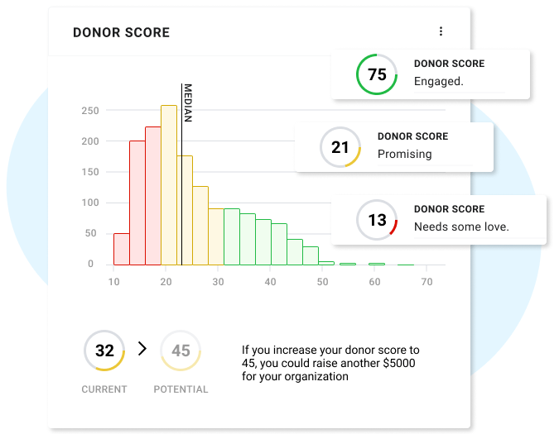

Fig 4.a: Sample of donor data collection and analysis using Keela analytic tool. Team, T.K. (2024)

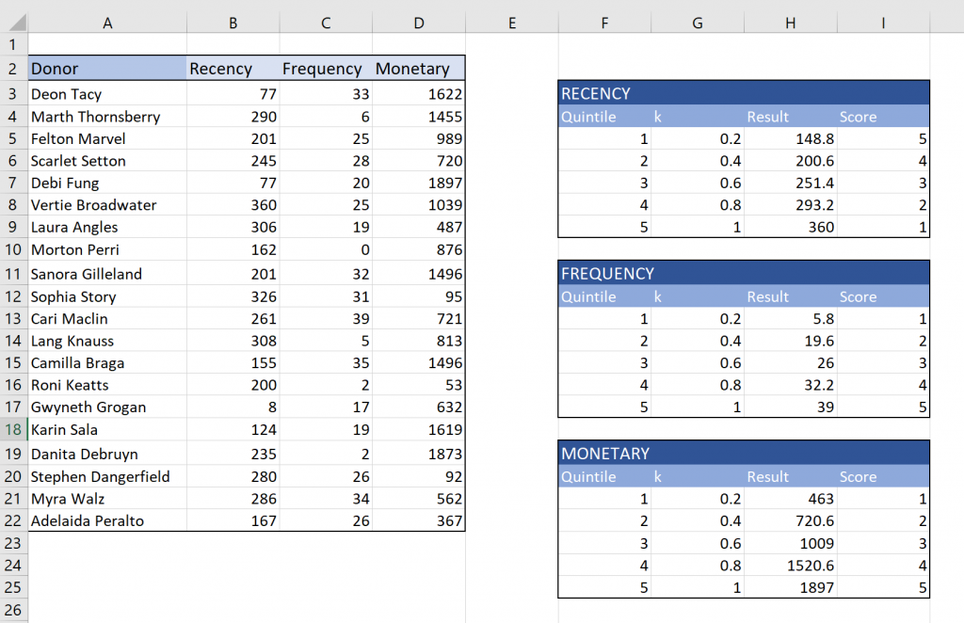

Fig 4.b: Sample of donor data collection and analysis using Keela analytic tool. Team, T.K. (2024)

## Crowdfunding campaign development

### Campaign messaging and storytelling

The success of any crowdfunding campaign lies in a good storyline. It should be able to connect with the target audience, touch the right chords, and persuade them to help in your cause. Here are the key factors to include while creating a campaigning story:

* Know Your Audience:
  + Do your homework and learn what they believe in, like to do, or are struggling with.
  + Show empathy: be in the other person's place and feel their experiences.
* Create a Tantalizing Story arc
  + Hook- Use an interesting story or statistic to start the article.
  + Problem: Describe the problem you are solving.
  + Solution: How your project will solve the issue
  + Benefit: Focus on what beneficial results your project makes.
  + Call to action: Present a solution and ask that your audience implement it too.
* Emotive Language: Use words that make you feel something.
  + Invest in storytelling: Incorporate personal stories and anecdotes within your narrative.
  + Emotion — evoke relatable human emotions like hope, empathy or fear that cause the audience to resonate with what you are discussing.
  + Imagery — create an image in your mind.
* Be Authentic and Transparent:
  + Really: be transparent about the difficulties and reality of your project.
  + Transparency: Let your donors know what you intend to do with the money.
  + Have an honest representation of yourself — show your enthusiasm even in the slightest way possible.
* Keep it Concise:
  + Keep your story brief and to the point.
  + In no-nonsense terms
* Proofread and Edit:
  + Accuracy – make sure your story is mistake-free.
  + Transparency: Ensure that you have clear messaging.
* Test Your Story:
  + Hey – check with friends, family and potential backers.
  + Iterative process: Take feedback and iterate



**"Nurturing Minds, Healing Hearts: Support Samye Foundation Wales"**  
Meet Sarah, a 35-year-old teacher who struggled with anxiety. Through Samye Foundation Wales’s mindfulness courses, she found peace and purpose. Now, Sarah volunteers at the centre, helping others on their journey to mental well-being. Your donation will ensure that more people like Sarah can access life-changing mindfulness training and support. Help us continue our mission of fostering mental health and resilience in our community.

Fig 5: Sample: Campaign story: For Mindfulness Practitioners and Mental Health Advocates



**"Rooting for Change: Grow with Samye's Mother Earth Project"**

Story: Picture our urban oasis in Cardiff, where bees buzz in our Bee Friendly certified gardens and community members gather to learn sustainable living practices. Through our Mother Earth Project, we're not just talking about environmental stewardship – we're living it. Your contribution will help us expand our eco-friendly initiatives, from reducing plastic use to hosting seminars on sustainable living. Join us in creating a greener, more mindful Wales for future generations.

These campaign messages are crafted based on the services and projects described on the Samye Foundation Wales website (Samye Foundation Wales, 2024) and tailored to the donor segments identified earlier. The storytelling approach is informed by best practices in nonprofit marketing and fundraising (NCVO, 2020).

Fig 6: Sample campaign story: For Environmental Enthusiasts and Local Community Members

### Reward Structure for the Donors

The key to effective fundraising incentives is understanding donors' preferences. Research shows that potential donors or those who haven't yet contributed are the ones most interested in rewards. Some donors want recognition to share their giving with others, while others prefer to stay private, feeling that rewards diminish the sincerity of their gift. To tailor incentives, ask your donors if they want recognition after donating. Include this question in your donation acknowledgment and track their responses. Observe how they engage with recognition, such as on social media or through email sharing. By offering donors the choice to opt-in for incentives, you show that you value their preferences and make them feel appreciated.

The Table 6 shows a example of how the Samye Foundation Wales can reward the donors for their charity.

|  |  |
| --- | --- |
| **Contribution Level (GBP)** | **Reward** |
| **10** | Digital mindfulness guide. |
| **25** | Access to a live online mindfulness session. |
| **50** | Recorded mindfulness meditation session + previous rewards |
| **100** | One-on-one mindfulness coaching session + previous rewards |
| **250** | Name recognition on website + personalized thank you video + previous video |
| **500** | Invitation to an exclusive in-person mindfulness retreat + previous rewards |
| **1000** | Patron status with special recognition + ongoing updates + all previous rewards |

Table 6: Sample of Reward Tier

Based on the activities and services offered by Samye Foundation Wales, Table 8 shows the reward samples for donors. Inspired by the services and projects detailed on the Samye Foundation Wales website, (Samye Foundation Wales 2024), as well as general reward categories from charity crowdfunding generally include NCVO 2020. This involves rewards carefully crafted to correspond with the foundation's mission and targeting chosen donor segments, each of them thankful in its own right.

|  |  |
| --- | --- |
| Operational Costs campaign | Mother Earth Project |
| Free or discounted access to mindfulness classes or workshops. | Sustainable living kits or products related to the project's initiatives. |
| Digital or printed meditation guides created by the foundation's experts | Opportunities to participate in gardening sessions or bee-friendly activities. |
| Exclusive guided tours of the Samye Foundation Wales centre | Access to exclusive workshops on sustainable living practices |
| Donor names displayed on a 'Supporters Wall' at the centre or on their website. | A tree planted in the donor's name as part of the foundation's environmental efforts. |
| One-on-one sessions with the foundation's therapists or counsellors | Handmade, environmentally-themed artwork created by local artists or community members |

Table 7: Reward Sample for Donors

### Campaign timeline and milestones

Based on crowdfunding best practices as outlined by NCVO (2020) and adapted to the specific context of Samye Foundation Wales (Samye Foundation Wales, 2024).

Pre-launch Phase (4-6 weeks):

* Week 1-2: Definition of goals and drafting rewards/messaging
* Week 3-4: Generate materials for campaign (videos, images, stories)
* Week 5-6: Tease campaign through social media and email

Soft Launch (1 week):

* Days 1–7: Messaging to Core Supporters, board members and volunteers
* Milestone: Aim for 20–30% of the goal before

Public Launch (4-6 weeks):

* Week 1 – Global official launch announcement across all channels
* Threads Week two: Launch — Virtual or in-person launch event
* Weeks 3-4: Updates and donor spotlights
* Week 5–6: Drive with urgency messaging
* Milestones:
  + 50% of goal by end of week 2
  + 75% of goal by end of week 4

Final Sprint (1 week):

* Day 1-7: Reach out to everyone on social media and in email
* Reach or exceed 100% of goal

Post-campaign (2-4 weeks):

* Week 1–2: Thank donors + Share campaign results
* Week 3-4: Share project budget, utilization and implementation

Some specific ideas for Samye Foundation Wales:

* Operational Costs Campaign
  + Consider a quieter time for launch, possibly early autumn.
  + This draws attention to the importance of donations in preserving and expanding services
* Campaign by Mother Earth Project:
  + Schedule the launch for Earth Day or another environmental awareness day.
  + Create milestone goals for more specific project outcomes (e.g., "When we are at 50%, that's when we can start our new sustainable garden")

### Digital marketing and social media strategy

Digital marketing and social media strategies have become vital tools for the success of crowdfunding campaigns. They provide a powerful platform to reach a wider audience, build relationships and generate support.

Website Integration:

* Creating a dedicated landing page on sfwales.org for each crowdfunding campaign will help give more information to the online website visitors. Prominent calls-to-action can be added to the homepage to link to the campaigns.

Email Marketing:

* Email marketing is a form of one-to-one marketing (Anon (2024)) that allows marketers to generate customisable storytelling for individuals or groups. Email marketing is easily automated to trigger events on websites or email chains.
* Send targeted emails to already enrolled participants and new joiners regarding announcing the campaign providing updates, and encouraging donations.
* An appreciation email could be sent to all the charity donors for their contribution to a great cause.

Social Media Campaign:

* Utilizing existing platforms where Samye Foundation Wales has accounts such as Facebook, Instagram, Twitter, etc to promote the campaigns.
* Creating campaign-specific hashtags (example: #SamyeMindfulnessFund, #MotherEarthProject)
* Improving engagement on the post on social media through the likes, comment and share. Refer to Fig 7 is a Facebook post by Canton and Riverside Community Group (Cardiff) on the Samye Foundation Wales Page. As of 30 Aug 2024, the post has a single Like, zero comments and share. Considering that the charity has 50 volunteers, there should be at least 50 engagements. Similar engagement condition is observed on all the platforms.
* Consider using social media management tools for scheduling and analytics such as Google Analytics and RivalIQ which do not charge any service fee for the usage.

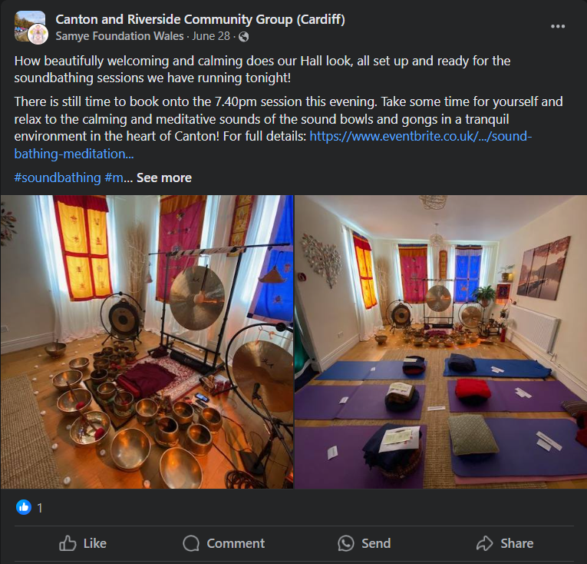

Fig 7: Facebook Post by Samye Foundation Wales (28 June 2024)

Content Strategy: The content created should be catered to a target audience and channel-specific. Refer Table 8 which has examples of content creation for specific audience and channels to publish.

|  |  |  |  |
| --- | --- | --- | --- |
| Target Audience | Content Focus | Channels | Content Example |
| Mindfulness Practitioners | In-depth articles on advanced mindfulness techniques | Blog posts on sfwales.org | 5 Advance Mindfulness Techniques to Deepen Your Practice |
| In-depth articles on advanced mindfulness techniques | YouTube channel for video content | Video Series: Mindfulness in Daily Life: A 30-day challenge |
| Interviews with mindfulness experts and teachers | Dedicated email newsletter | Podcast: Conservations with Mindfulness Masters |
| Mental Health Advocates | Research-based articles on the benefits of mindfulness for mental health | Blog posts with scientific citations | "The Science Behind Mindfulness and Anxiety Reduction" |
| Personal stories of mental health improvement through mindfulness | Social media (particularly LinkedIn and Twitter) | Infographic: "Mindfulness vs. Medication: Comparing Approaches to Mental Health" |
| Infographics on mental health statistics and mindfulness impact | Partnerships with mental health organizations for a guest post | Case study: "How Mindfulness Training Reduced Workplace Stress by 30%" |
| Environmental Enthusiasts: | Articles linking mindfulness and environmental awareness | A dedicated section on the website for the Mother Earth Project | "Mindful Consumption: How Awareness Can Reduce Your Carbon Footprint" |
| Practical tips for sustainable living | Instagram for visual content (e.g., garden progress, eco-friendly practices) | Instagram Story series: "A Day in Our Bee-Friendly Garden" |
| Updates on the Mother Earth Project progress | Collaboration with environmental bloggers | Blog post: "10 Mindful Habits for a More Sustainable Lifestyle" |
| Local Community Members | News about local events and workshops | Local newspaper columns | "Samye's Impact: How We're Making Cardiff a More Mindful City" |
| Stories of community impact | Community Facebook groups | Facebook Event: "Community Mindfulness Walk in Bute Park" |
| Volunteer opportunities and local partnerships | Flyers and posters in local businesses | Local newsletter: "5 Ways Samye is Supporting Mental Health in Cardiff" |
| Corporate Wellness Advocates | ROI of mindfulness programs in the workplace | LinkedIn articles and sponsored content | LinkedIn article: "The Bottom Line of Mindfulness: How It Boosts Your Company's Productivity" |
| Case studies of successful corporate mindfulness initiatives | Webinars and online workshops | Webinar: "Implementing a Successful Corporate Mindfulness Program" |
| Tips for implementing mindfulness in busy work environments | White papers and downloadable guides | Downloadable guide: "The HR Manager's Toolkit for Workplace Mindfulness" |
| Complementary Therapy Users | Articles on the integration of mindfulness with other therapies | Blog posts on sfwales.org | "Mindfulness and Massage: A Powerful Combination for Stress Relief" |
| Profiles of Samye's therapists and their approaches | In-centre brochures and information sheets | Therapist spotlight series: "Meet Our Experts" |
| Tips for holistic well-being | Targeted email campaigns | Email series: "Your Holistic Health Journey with Samye" |
| Buddhist Community: | Articles on Buddhist philosophy and its application in modern life | Dedicated section on the website for Buddhist content | "Applying Buddhist Principles to Modern Work Life" |
| Information on Buddhist events and retreats | Partnerships with Buddhist publications for content sharing | Event announcement: "Weekend Retreat with Visiting Tibetan Lama" |
| Teachings from visiting Buddhist masters | Specialized email list for Buddhist community members | Email series: "Exploring the Four Noble Truths in Daily Life" |

Table 8: Examples for content creation strategy.

Create a 360-marketing strategy powered by influencer partnerships, social proof, community engagement, paid advertising and cross-promotion to magnify Samye Foundation Wales' campaign. Amassing interest through hyper-local influencers on wellness and environment categories, enabling them with campaign kits to amplify our reach of getting new supporters. In addition to visual graphics that display the number of donors and how much has been raised, showcasing donor spotlights strengths relatedness with hero quality reinforcements while displaying a live feed will improve social proof. Finally, to build a sense of community, run virtual events (think webinars), Q&A sessions and have an official forum etc. Use targeted ad campaigns, retargeting as well Google Ad Grants to drive donations and collaborate with our partner organizations around cross-promotion. Adding a countdown timer, creating limited edition rewards and encouraging donations towards team milestones to drive that sense of urgency. After the campaign, share impact and invite donors to special events. This approach was based on nonprofit digital marketing best practices and modified to Samye Foundation Wales, while integrating successful elements of crowdfunding campaigns.

## Monitoring, Evaluation and Learning

### Monitoring Strategy

* + 1. Real-time Data Tracking:
       - Monitor daily KPIs: Total funds raised, no. of donors and average donation size (Choy & Schlagwein 2016)
       - For example: Monitor daily completion progression towards the £30,000 and £20,000 goals in crowdfundinguk.
    2. Donor Engagement Monitoring:
       - Measure social media engagement (comments, shares, likes) on the campaign page and per platform (Mollick 2014).
       - Example: Monitor shares and comments on Facebook posts related to the divisible Memory of Mankind project Mother Earth.
    3. Website Traffic Analysis:
       - Track the traffic from your crowdfunding page to Samye Foundation Wales's website using tools such as Google Analytics (Charity Digital, 2021).
       - For example: Count the number of people to sfwales. org being used from the CrowdfundingUK campaign page.

### Evaluation Methods

* + 1. Quantitative Analysis:
       - Measure the performance of each campaign against established Key Performance Indicators (KPIs) (NCVO, 2020).
       - Example KPIs:
         1. Percent (%) Of Milestone Reached (e.g., 80% of £30,000 operational costs)
         2. Number of new donors acquired
         3. Average donation size
    2. Qualitative Feedback:
       - Survey current donors (Gerber and Hui, 2013) — good article showing two methods of conducting interviews with existing endowments.
       - For instance: send a post-donation survey to see why, how and if the donors really believe in what you are doing on behalf of Mother Earth.
    3. Campaign Timing Analysis:
       - Judge how different campaign phases are effective (launch, mid-campaign, final push) (Kuppuswamy and Bayus 2018).
       - For example, compare donation rates in operation costs campaign first month and last.

### Learning and Adaptation

* + 1. Mid-campaign Reviews:
       - Hold bi-weekly reviews to see what is happening - and adjust the approach as required (NCVO, 2020).
       - For Example, if your Mother Earth project is lagging after three months, maybe it will be helpful to tweak the messaging or roll out new rewards.
    2. Cross-campaign Learning:
       - Use inputs from a save expense crusade to create the Mother Earth venture (Choy and Schlagwein, 2016).
       - For Example, if you found that video updates work well in the operational costs campaign, include more videos in the Mother Earth project campaign.
    3. Donor Segmentation Analysis:
       - Analyse which types of appeals resonate the most with each donor segment (Gerber and Hui, 2013).
       - For Example, Increase the reach and engagement with the Mother Earth project by Environmentalists in case if so, future communications should only be about this cause.
    4. Post-campaign Retrospective:
       - Review and learn — fully review after each campaign [NCVO, 2020].
       - For instance, gather the team for a meeting to talk about what went well and what could be done better in future campaigns.

Through this monitoring, evaluation, and learning approach, Samye Foundation Wales will optimise its crowdfunding campaigns for both organizational overheads as well as the Mother Earth project. Adopting this methodology will now help the charity in its decision making with data and make better predictions on future donor engagement which actually gives the organization a lot more visible control over their fundraising targets.

## Recommendations

### Prioritised recommendation

Set Clear Goals and KPIs

Set quantifiable goals for each campaign that go beyond just the financial accomplishments. For example:

* Operational cost project (£30,000 at the end of year 1)
  + Acquire 550 new donors, considering £58 as an average donation amount. (Charities Aid Foundation. (2023))
  + 50% of target in the first quarter of the year
* Mother Earth Project (6 months to £20,000)
  + Get 350 new environmental activists involved
  + 80% of target completed in first four month

Implement Real-Time Tracking

Check in on the important data of your Crowdfunding UK campaign every day with cloud-based analytics dashboard:

* Total funds raised per day/week
* Number of new donors
* Average donation size
* Traffic sources to campaign page

Run frequent campaign checks Bi-weekly reviews with when to evaluate progress and modify strategies:

* + - * + Analyse performance against KPIs.
        + Analyse response rates of social posts and campaign page. For Example, determine which content and donor segments performed best.

Gather Qualitative Feedback, Survey donors and do an interview

* + - * + Follow up online with post-donation surveys to get under the skin of what makes these supporters give in the first place.
        + Do more in-depth interviews with major donors.
        + Collect data of volunteers and staff working on a campaign.

Analyse Donor Segments and evalute which donor segments respond the most:

* + - * + Track engagement by segment (example: across mindfulness practitioners, versus environmental enthusiasts).
        + Determine what appeals work for each segment
        + Revise messaging and reach out strategy accordingly

Determine when your campaign will run and different stages of the campaign.

* + - * + Analyse the performance of each phase: Donation Rates by Launch, Mid-campaign & Final Push.
        + Determine when to best post on social media and send emails
        + Changing when big news or matching funds are made available. (Note: This will be the easiest one of all to actually do.

Cross-Campaign Learning: Use learning from the cost of operation campaign to attract more followers and coverage on Mother Earth project:

* + - * + Learn from the success of your previous campaign
        + Migrate these strategies in the second campaign
        + Episode overview of how you can heatmap two campaigns: - Performance metrics comparison between the two Advertisements

Execute Analytics Post-Campaign: Conduct a detailed analysis after every campaign:

* + - * + Analyse the entire success including first goals and their KPIs
        + What the major successes and obstacles – was it culture or process?
        + Lessons learned and suggested future voter suppression campaign best practices.

Use Lessons as Building Blocks for the Future, leverage lessons learned for future fundraising and engagement strategies.

* + - * + Update your donor personas from learnings of campaign data
        + Refine messaging and communication tactics
        + Identifying potential new funding streams or ways to get involved

The prioritised plan is in line with a methodical rhythm of monitoring, assessment and learning from the Crowdfunding campaigns guided by best practices identified within crowdfunding (NCVO 2020) specified to Samye Foundation Wales context (Samye Foundation wales,2024).

### Implementation Plan, Ongoing support and Evolution

* + 1. Implementation Plan:
       - Pre-launch Phase (4-6 weeks)
         * Determine Campaign Goals and Messaging. Build campaign assets (videos, images and stories)
         * Create CrowdfundingUK platform pages for both campaigns
         * Email lists and social workout content calendar.
         * Campaign objectives and roles for staff and volunteers trained with.
       - Soft Launch (1 week)
         * Contact core supporters, Board members and volunteers
         * Test campaign messaging and donation process.
         * Collect early feedback and iterate if needed
* Public Launch
  + Operational Costs project Campaign (12 months)
    - Month 1 – 3: Focus on building momentum & get to a fast run rate at 35% pace of the goal.
    - Month 4-6 — Mid-campaign push, target 70% of goal
    - Months 7–12: Contact lapsed donors and new prospects for final push to reach or exceed the target.
* Mother Earth Project Campaign (6 months)
  + Month 1-2: Strong launch, targeting 30% of goal
  + Month 3-4: Showcase project milestones and success stories.
  + Month 5–6: Last push — Race to £20,000

### Ongoing Support:

* + - * Regular Communication
        + Give weekly update to donors via email and social media
        + Monthly key performance indicator reports on the Samye Foundation Wales website
        + Custom thank-you messages for ALL donations
* Donor Engagement
  + Virtual events (e.g., online meditation classes, environmentally friendly workshops)
  + Give donors access to special content or experiences (e.g., backstage passes)
  + Opt-in Social Sharing When Donors Share With Each Other
* Campaign Optimization
  + Construction team meetings weekly to track progress and adjust strategies.
  + Message and creative A/B testing for campaigns
  + Ongoing optimization of the donor journey as feedback is received.
* Technical Support
  + Quick assistance with any donation’s issues process
  + Mobile Responsive of All Campaign Materials
  + Daily monitoring for all campaign link checks and functionality.

### Evaluation Approach:

* + - * Quantitative Metrics
        + Monitor progress towards financial goals (30k and 20k)
        + Watch for: Donor counts, Average amount given per donor Retention rate
        + Evaluate website traffic and social media performance
* Qualitative Feedback
  + Conduct mid-campaign surveys with donors
  + Feedback from the end users and beneficiaries
  + Conduct focus group sessions with stakeholders (trustees, volunteers) for feedback on campaign perception
* Comparative Analysis
  + Compare performance the 2 campaigns
  + Compare to other similar charity campaigns
  + Examine the performance of distinct forms of communication and message delivery
* Impact Assessment
  + A Measure of How Well Funds Raised Support the Organization
  + Reviewing progress of Mother Earth project initiatives
  + Measurement increase in community engagement and awareness
* Long-term Evaluation
  + Conduct a 6-month post-campaign review. Involve stakeholders and donors.
  + We can evaluate donor retention and engagement past the campaign period
  + Review the effect of this grant on Samye Foundation Wales's financial stability and project delivery

The reason for doing all this is not just to help achieve the success of these crowdfunding campaign we will be working on with Samye Foundation Wales but also provide wider insights into fundraising activity far beyond what your "normal" crowdfunding company would offer.

## Reference

Alumnifinder (2024) Donor Data: 6 Best Practices for Data Management and Hygiene. Available at: <https://www.alumnifinder.com/blog-donor-data/> (Accessed: 29 August 2024).

Anon (2024). *One-to-One Marketing: Examples, Strategy, Pros and Cons* [Online]. Available at: <https://ppcexpo.com/blog/one-to-one-marketing-examples> [Accessed: 30 August 2024].

Business Wales, 2024. Crowdfunding. [Online] Available at: <https://businesswales.gov.wales/businessfinance/types-finance-and-how-apply/crowdfunding> [Accessed: 20 August 2024].

Charities Aid Foundation. (2023) Today we launch our Corporate Giving by FTSE 100 companies report [LinkedIn post] 19 June. Available at: <https://www.linkedin.com/posts/charitiesaidfoundation_today-we-launch-our-corporate-giving-by-activity-7086623361790799874-xMFL> (Accessed: 27 August 2024).

Charity Digital (2021) The best online fundraising platforms for charities. Available at: <https://charitydigital.org.uk/topics/the-best-online-fundraising-platforms-for-charities-5324> (Accessed: 29 August 2024).

Charity Digital (2021) The best online fundraising platforms for charities. Available at: <https://charitydigital.org.uk/topics/the-best-online-fundraising-platforms-for-charities-5324> (Accessed: 29 August 2024).

Choy, K. and Schlagwein, D. (2016) 'Crowdsourcing for a better world: On the relation between IT affordances and donor motivations in charitable crowdfunding', Information Technology & People, 29(1), pp. 221-247.

Cornershopcreative (2024) Tips for Collecting and Using Your Nonprofit's Donor Data. Available at: <https://cornershopcreative.com/blog/tips-for-collecting-and-using-donor-data/> (Accessed: 29 August 2024).

Gerber, E.M. and Hui, J. (2013) 'Crowdfunding: Motivations and deterrents for participation', ACM Transactions on Computer-Human Interaction, 20(6), pp. 1-32.

Good Finance (2019) Crowdfunding for Charities and Social Enterprises. Available at: <https://www.goodfinance.org.uk/latest/post/crowdfunding-charities-and-social-enterprises> (Accessed: 29 August 2024).

Kindful (2024) 4 Steps To Organizing & Categorizing Your Donors. Available at: <https://kindful.com/blog/how-to-organize-your-donor-list/> (Accessed: 29 August 2024).

Kuppuswamy, V. and Bayus, B.L. (2018) 'Crowdfunding creative ideas: The dynamics of project backers', in Cumming, D. and Hornuf, L. (eds.) The economics of crowdfunding. Cham: Palgrave Macmillan, pp. 151-182.

Localgiving (2024) Samye Foundation Wales. Available at: <https://localgiving.org/charity/samye-foundation-wales> (Accessed: 29 August 2024).

Localgiving (2024) Samye Foundation Wales. Available at: <https://localgiving.org/charity/samye-foundation-wales> (Accessed: 29 August 2024).

Mollick, E. (2014) 'The dynamics of crowdfunding: An exploratory study', Journal of Business Venturing, 29(1), pp. 1-16.

NCVO (2020) How to run a crowdfunding campaign. Available at: <https://www.ncvo.org.uk/help-and-guidance/funding-income/fundraising-methods/how-run-crowdfunding-campaign/> (Accessed: 29 August 2024).

NCVO (2020) How to run a crowdfunding campaign. Available at: <https://www.ncvo.org.uk/help-and-guidance/funding-income/fundraising-methods/how-run-crowdfunding-campaign/> (Accessed: 29 August 2024).

NCVO (2020) How to run a crowdfunding campaign. Available at: <https://www.ncvo.org.uk/help-and-guidance/funding-income/fundraising-methods/how-run-crowdfunding-campaign/> (Accessed: 29 August 2024).

Nesta (2024) Crowdfunding: why charities, social entrepreneurs and community groups should get on board. Available at: <https://www.nesta.org.uk/blog/crowdfunding-why-charities-social-entrepreneurs-and-community-groups-should-get-on-board/> (Accessed: 29 August 2024).

NICVA (@NICVA). (2022) Fewer people are giving to charity due to the cost of living crisis [Twitter] 25 July. Available at: <https://twitter.com/NICVA/status/1551584809704726528> (Accessed: 27 August 2024).

NPO Info (2024) Donor Data Management: A Quick Guide for Nonprofits. Available at: <https://npoinfo.com/donor-data-management/> (Accessed: 29 August 2024).

Register of Charities (2024) SAMYE FOUNDATION WALES. Available at: <https://register-of-charities.charitycommission.gov.uk/charity-search/-/charity-details/4034813> (Accessed: 29 August 2024).

Samye Foundation Wales (2024) Home. Available at: [https://sfwales.org](https://sfwales.org/) (Accessed: 29 August 2024).

Shoorah (2024) Shoorah's Crowdfunding Success: Paving the Path to Mental Health, Wellbeing, Mindfulness and Inner Calm. Available at: <https://shoorah.io/shoorahs-crowdfunding-success-paving-the-path-to-mental-health-wellbeing-mindfulness-and-inner-calm/> (Accessed: 29 August 2024).

Team, T.K. (2024) *Using your database to identify major donors*, *Keela*. Available at: <https://www.keela.co/blog/nonprofit-resources/using-your-database-to-identify-major-donors> (Accessed: 30 August 2024).

VWV (2024) Crowdfunding Campaigns, Compliance and Charity Law. Available at: <https://www.vwv.co.uk/news-and-events/blog/charity-law-brief/crowdfunding-campaigns-compliance-charity> (Accessed: 29 August 2024).

VWV (2024) Crowdfunding Campaigns, Compliance and Charity Law. Available at: <https://www.vwv.co.uk/news-and-events/blog/charity-law-brief/crowdfunding-campaigns-compliance-charity> (Accessed: 29 August 2024).

## Appendix

### Problem Statement

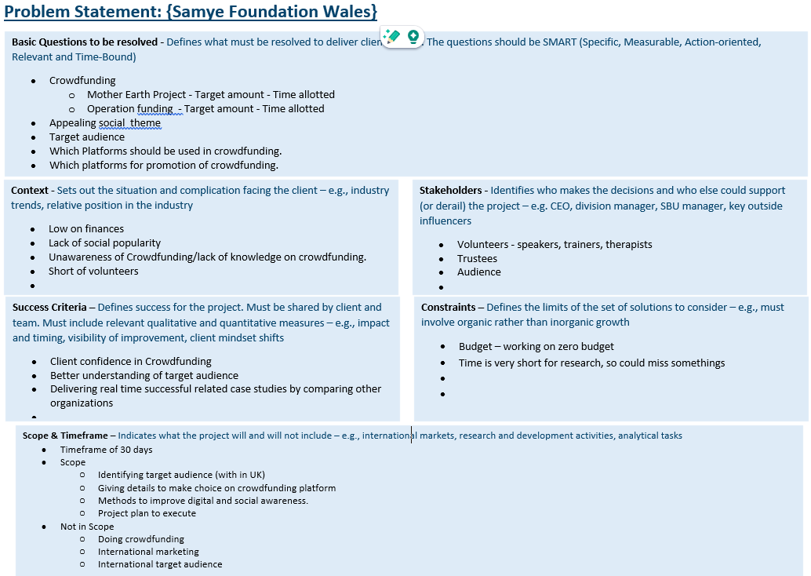 Fig 8: Problem statement

### Gantt Chart

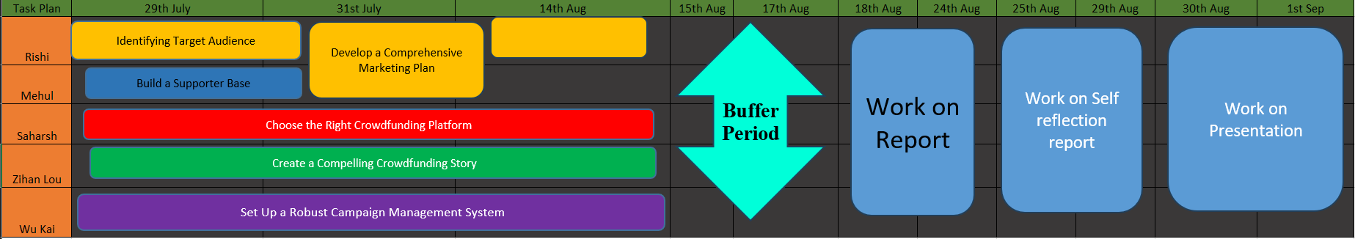 Fig 9: Gantt chart – timeline of the project

### Ethical Certificate submission Proof

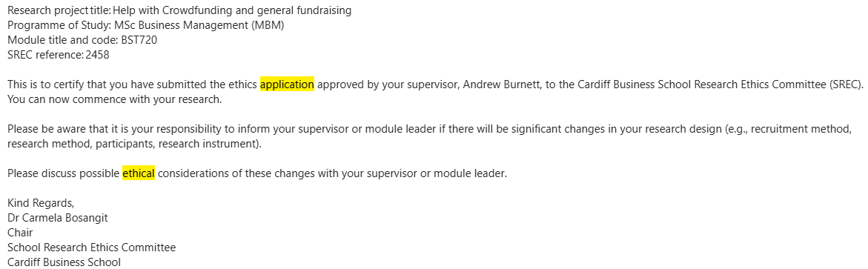

Fig 10: Ethical certificate submission’s proof email

### Questions & Feedback

Questions asked to the client during the start of the project and there feedback given to us from the client are as follows:

Date 25th July 2024

Organization: The Samye Foundation Wales

Services: the help which Samye Foundation Wales provides

Question

1. Target goal for the crowdfunding

1.1. For Mother Earth project: £20,000

1.2. For organization’s operations: £33,000 (spread over 1 years)

2. Target for the bare minimum from crowdfunding

2.1. For Mother Earth project: £10,000

2.2. For organization’s operations: £33,000

3. Time limit (months) for the crowdfunding project? 6 months

4. Campaign story:

4.1. Mother Earth ?

MEG is our Mother Earth Group Project dedicated to environmental sustainability and mental well-being. The mission is to protect the environment, restore hope in what an individual can do to work with climate change, promote sustainable living and provide mindfulness training to individuals. The aim is to help them alleviate stress, anxiety and improve their mental health and well-being. Our unique approach integrates mindfulness and sustainable development, recognising their interconnectedness and the transformative potential they hold when combined. We feel we can make valuable changes in people’s lives and regularly consult with the community to identify who will benefit from the MEG and involve them in discussions. We also recognise that we are in a fortunate position as we have our own dedicated building with a hall and many therapy rooms, thereby avoiding room hire costs for the project.

The BBC news reported in 2022 that young people in their teens are experiencing a lack of hope with regards to our climate and feel hopeless in what they can do individually. With our expertise in Mindfulness, coupled with environmental approaches, the project will help us design and deliver a 6 week MEG course which combines mindfulness skills to work on a person’s inner environment, coupled with creating a sense of hope when working in the environment, as well as pointing the local community to other wellbeing courses at the centre. Also, access to psychotherapists, counsellors, shiatsu and holistic therapy already established in our centre which we will deliver. We will combine Joanna Macy’s work with Mindfulness to create the new course, especially Active Hope: How to Face the Mess We're In Without Going Crazy" co-authored by Joanna Macy and Chris Johnstone, along with examples of evidence that support these points. See supporting literature.

The new Volunteer MEG Events Co-ordinator will attract new volunteers to the MEG project and courses. They will work with existing volunteers by creating events that will be held at the centre and elsewhere for wellbeing, thereby creating a deeper understanding in working with our environment and instilling a greater sense of hope for the future. We will provide:

1. Mindfulness and Mental Well-being: Our centre offers mindfulness courses, yoga and t’ai chi sessions, meditation classes and nature walks. This enables individuals to develop a deeper connection with nature, reduce stress, anxiety, depression and foster mental well-being.

2. Sustainable Living: Through our "get-together" groups we will educate people on living more sustainably with the Earth, highlighting the importance of sustainable choices and their impact on the environment.

3. Individual Action: We will empower individuals by demonstrating how their actions can make a significant difference to the environment. By promoting individual responsibility, we aim to inspire proactive environmental consciousness by working on our inner and outer environment.

4. Environmental Education: We plan to invite environmental speakers to give talks and conduct workshops on various topics related to environmental sustainability and wildlife conservation. These educational events will be integrated into our mindfulness courses, providing participants with knowledge and inspiration to take action for the environment.

5. Outdoor Workshops: Our outdoor workshops will focus on practical skills, such as gardening, organic growing, foraging and survival techniques, working with partner environmental organisations already established in Cardiff. These activities will not only teach valuable skills, but also foster a deeper appreciation for nature.

6. Carbon Footprint Awareness: We will raise awareness about personal carbon footprints and provide tools and resources to help individuals reduce their environmental impact.

We will continue to create a tranquil space for the local community to enjoy and have plans to incorporate a small pond for wildlife, as well as increase the variety of birds to our garden.

Through the new MEG course and other activities at the centre we will create opportunities for volunteers to thrive and promote wellbeing in our tranquil environment.

Our green skills combined with mindfulness courses will aim towards educating the community to achieve the Government's net zero and wider environmental ambitions.

Ecological mindfulness interventions incorporate mindfulness practices with a specific emphasis on connecting with nature, promoting environmental awareness and fostering sustainable behaviours. These interventions have shown to increase participants' sense of connection to the natural world, reduce stress and improve overall wellbeing, by fostering a deeper appreciation for the environment. (Source: Ryan, R. M. et al. (2009). Mindfulness and Nature: A Sustainable Connection).

Study: "Mindfulness Increases Pro-Environmental Behavior: Experimental Evidence"

- Conducted by Ding, D., & Epstein, D. R. (2015)

- Findings: Participants who engaged in mindfulness practices exhibited more pro-environmental behaviour, such as recycling and reducing energy consumption, compared to control groups.

Mindfulness, as the practice of being present in the moment with non-judgmental awareness, plays a crucial role in promoting sustainable development practices. By cultivating mindfulness, individuals and communities develop the awareness, empathy and compassion necessary to make sustainable choices and build resilience in the face of environmental challenges. We want young minds to feel empowered to be part of the solution to restore and repair our planet.

4.2. Why fund the organization?

Samye Foundation Wales is a dedicated centre in the heart of Cardiff with it’s own premises that is a haven of tranquility for everyone. The organisation became a charity in 2008 and since then has provided hundreds of courses throughout the South Wales Valleys and Cardiff. The people that deliver mindfulness are highly qualified in their field and have over 35 years of experience in mindfulness. We pride ourselves in our high standards. We look after our volunteers and have currently about 20 active volunteers.

There is something for everyone at our centre – whether it is enjoying the peace in our tranquil gardens or attending different activities at the centre.

We are easily accessible and are on a major bus route into the City centre.

5. Services provided by the organization?

5.1. Free services : meditation classes, mindfulness classes, free mindfulness courses and workshops for volunteers

5.2. Paid services : Mindfulness is delivered to organisations – we do talks and courses.

6. What offers the organization can make to the donors.

6.1. For supporters of our centre they can attend a retreat day a month, borrow books from our reading room, use the space in the day to meditate, discount on paid courses

6.2. Supporters can use our facilities to meditate, read, work on their laptop

7. General expense and funding amount per annum? (to find if you can spend on marketing and other things or not)?

At the moment we have no funding to spend on marketing. We print our own posters which are displayed in various places and our spend for paper, toners and ink is about £150 over 3 months

8. Social media activities and their follow ups?

We advertise regularly on facebook and instagram and the site is monitored by volunteers. We also advertise on meetup